# **RMI**

## **Program-1 Upper Case**

Now client can call methods on the server.

Now client can call methods on the server in-turn server can call methods on the client.  
Result is sent back to the client.

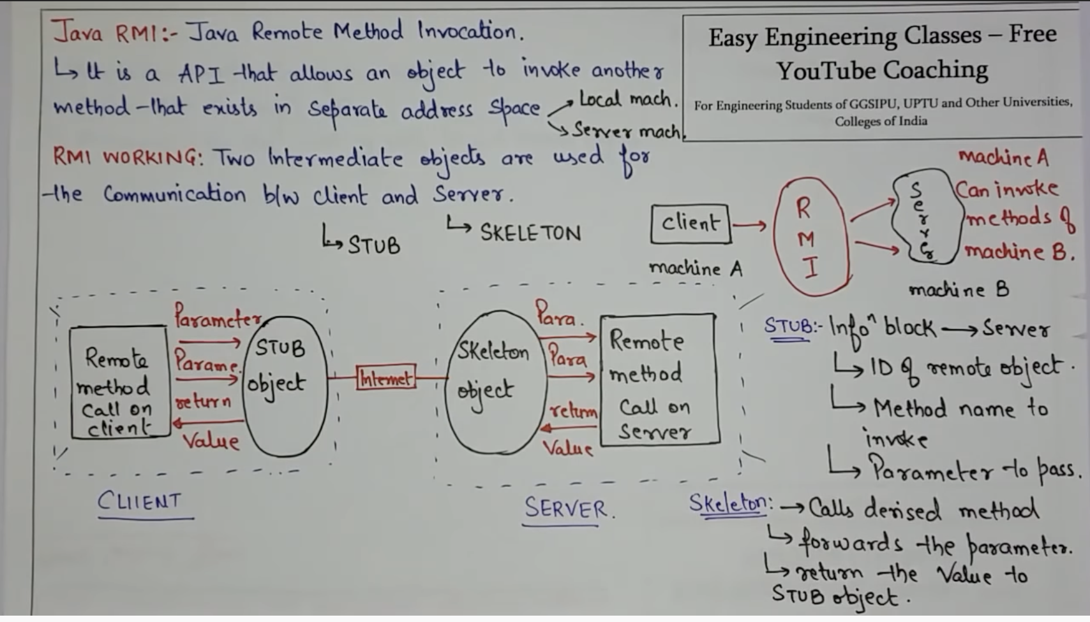

A1 is the fetched object -> calls the method m1()

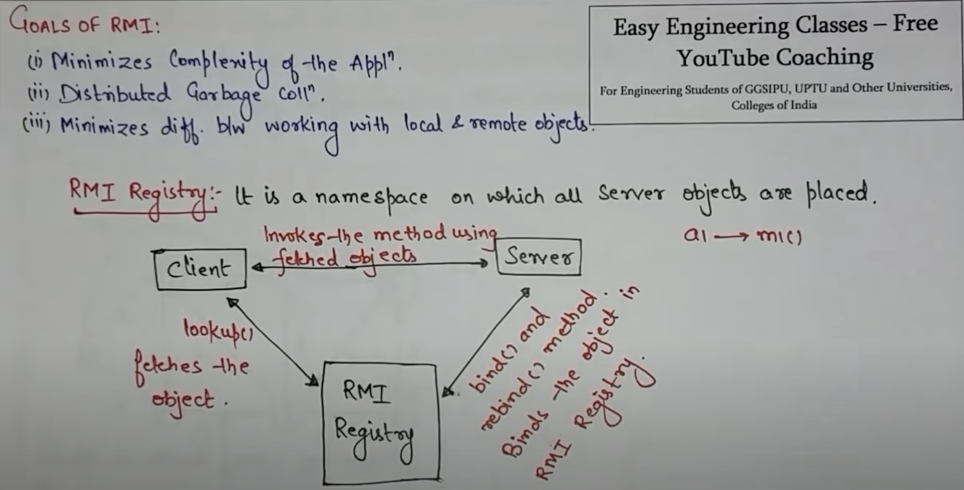

Server defines the object and binds in the registry.

Client fetches the object from the registry.  
These fetched object will call the method on the server.

* rmic add_interface_implement.java
* rmiregistry

Compile and Run the server code

Compile and Run the client code

# **References**

<https://www.youtube.com/watch?v=FX5hR-np-sg>

<https://www.youtube.com/watch?v=kyluPcfsyLU>